Project Design Phase-II
Technology Stack (Architecture & Stack)

Date | 18 February 2026
Team ID | LTVIP2026TMIDS80016
Project Name | Flavour Fusion: AI- Driven Recipe Blogging
Maximum Marks | 4 Marks

Technical Architecture:
The Deliverable shall include the architectural diagram as below and the information as per the table1 & table 2
Example: Flavour Fusion: AI- Driven Recipe Blogging
Guidelines:
Include all the processes (As an application logic / Technology Block)
Provide infrastructural demarcation (Local / Cloud)
Indicate external interfaces (third party API’s etc.)
Indicate Data Storage components / services
Indicate interface to machine learning models (if applicable)
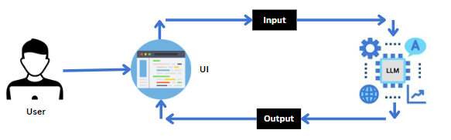

Table-1 : Components & Technologies:
S.No | Component | Description | Technology
 | User Interface | Web-based dashboard for blog generation, ingredient input, and photo uploads. | Streamlit, HTML, CSS
 | Application Logic-1 | Core process handling state management, API calls, and text processing. | Python 3
 | Application Logic-2 | Multimodal analysis logic to bridge image data with LLM prompts. | Pillow (PIL)
 | Application Logic-3 | Engagement utility to fetch and display random programmer jokes during latency. | Python (randomize logic)
 | Database | Secure management of API keys and project environment variables. | .env(Dotenv)
6. | File Storage | Temporary storage for uploaded image files and exported recipe .txt files. | Local Filesystem
7. | External API-1 | Large Language Model service for text generation and recipe reasoning. | Google Gemini 2.5 Flash API
8. | Machine Learning Model | Purpose-built model for object/dish recognition and content generation. | Gemini 2.5 Flash (LLM)
9. | Infrastructure | Deployment environment for hosting the Streamlit application. | Local Server / Streamlit Cloud

Table-2: Application Characteristics:

S. No | Characteristics | Description | Technology
 | Open-Source Frameworks | Fast, interactive UI framework for data-centric Python apps | Streamlit
 | Security Implementations | Use of environment variables to prevent API key exposure in source code. | Python-Dotenv
 | Scalable Architecture | Decoupled frontend/backend allowing for easy integration of more ML models. | 3-Tier Modular Architecture
 | Availability | Web-accessible deployment via cloud hosting services. | Streamlit Community Cloud
 | Performance | Optimized latency management using asynchronous UI updates and "loading" states. | Streamlit Status Containers

References:
• Google Generative AI Documentation: https://ai.google.dev/
• Streamlit Documentation: https://docs.streamlit.io/
• IBM Architecture Center: https://www.ibm.com/cloud/architecture

